CPE301 – SPRING 2019

Design Assignment 6

Student Name: Kyungseo Yun

Student #: 2001091216

Student Email: yunk93@unlv.nevada.edu

Primary Github address: <https://github.com/biscuit0x/submission_yun.git>

Directory: submission_yun/DesignAssignments/DA2B/

Submit the following for all Labs:

1. In the document, for each task submit the modified or included code (only) with highlights and justifications of the modifications. Also, include the comments.
2. Use the previously create a Github repository with a random name (no CPE/301, Lastname, Firstname). Place all labs under the root folder ESD301/DA, sub-folder named LABXX, with one document and one video link file for each lab, place modified asm/c files named as LabXX-TYY.asm/c.
3. If multiple asm/c files or other libraries are used, create a folder LabXX-TYY and place these files inside the folder.
4. The folder should have a) Word document (see template), b) source code file(s) and other include files, c) text file with youtube video links (see template).

1. Components : atmega328p, multi-shield, gyro sensor(mpu6050)

2. Code

/*

* GccApplication1.c

* Author : jayne

*/

#ifndef F_CPU

#define F_CPU 16000000UL

#endif

#include <avr/io.h>

#include <util/delay.h>

#include <math.h>

#include <stdlib.h>

#include <stdio.h>

#include "inc\MPU6050_def.h"

#include "inc\i2c_master.h"

#include "inc\uart.h"

float Acc_x, Acc_y, Acc_z, Gy_x, Gy_y, Gy_z;

void read(void);

void MPU6050_init(void);

int main(void){

char buffer[20], float_[10];

float x_a, Y_a, Z_a, X_g, Y_g, Z_g;

MPU6050_init();

USART_Init(9600);

i2c_init();

while(1){

read();

x_a = Acc_x/16384.0; /*Divide raw value by sensitivity scale factor to get real values */

Y_a = Acc_y/16384.0;

Z_a = Acc_x/16384.0;

X_g = Gy_x/16.4;

Y_g = Gy_y/16.4;

Z_g = Gy_z/16.4;

dtostrf( x_a, 3, 2, float_ ); /* Take values in buffer to send all parameters over USART */

sprintf(buffer,"Ax: %s, ",float_);

USART_SendString(buffer);

dtostrf( Y_a, 3, 2, float_ );

sprintf(buffer,"Ay: %s, ",float_);

USART_SendString(buffer);

dtostrf( Z_a, 3, 2, float_ );

sprintf(buffer,"Az: %s, \n",float_);

USART_SendString(buffer);

dtostrf( X_g, 3, 2, float_ );

sprintf(buffer,"Gx: %s, ",float_);

USART_SendString(buffer);

dtostrf( Y_g, 3, 2, float_ );

sprintf(buffer,"Gy: %s, ",float_);

USART_SendString(buffer);

dtostrf( Z_g, 3, 2, float_ );

sprintf(buffer,"Gz: %s, \n\n",float_);

USART_SendString(buffer);

_delay_ms(1000);

}

return 0;

}

void read(void){ //read gyro sensor value

i2c_start(0xD0);

i2c_write(ACCEL_XOUT_H);

i2c_stop();

i2c_start(0xD1);

Acc_x = (((int)i2c_read_ack()<<8) | (int)i2c_read_ack());

Acc_y = (((int)i2c_read_ack()<<8) | (int)i2c_read_ack());

Acc_z = (((int)i2c_read_ack()<<8) | (int)i2c_read_ack());

i2c_stop();

i2c_start(0xD0);

i2c_write(GYRO_XOUT_H);

i2c_stop();

i2c_start(0xD1);

Gy_x = (((int)i2c_read_ack()<<8) | (int)i2c_read_ack());

Gy_y = (((int)i2c_read_ack()<<8) | (int)i2c_read_ack());

Gy_z = (((int)i2c_read_ack()<<8) | (int)i2c_read_ack());

i2c_stop();

}

void MPU6050_init(void){ //gyro sensor initialization

_delay_ms(150);

i2c_start(0xD0); //write addr

i2c_write(SMPLRT_DIV); //1KHz sample rate

i2c_write(0x07);

i2c_stop();

i2c_start(0xD0); //power mgnt reg

i2c_write(PWR_MGMT_1);

i2c_write(0x01);

i2c_stop();

i2c_start(0xD0); //configuration reg

i2c_write(CONFIG);

i2c_write(0x00); //8Khz

i2c_stop();

i2c_start(0xD0);

i2c_write(GYRO_CONFIG); //range +/2000

i2c_write(0x18);

i2c_stop();

i2c_start(0xD0);

i2c_write(INT_ENABLE); //enable interrupt

i2c_write(0x01);

i2c_stop();

}

3. Schematic

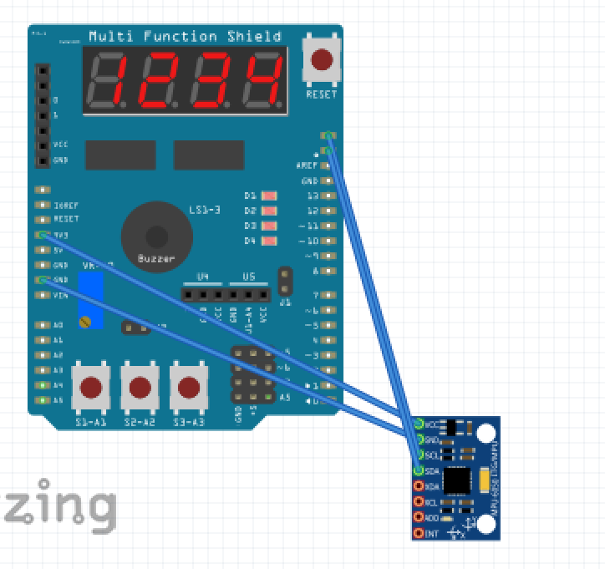

4. Photo

